MACD-Xrossing

Find new candidates for a CHARM trade
MACDX searches for stocks you do not already own whose blue daily MACD line recently crossed above the gold signal line and remains above it. It narrows the market, tests past examples and gives you a sortable list of candidates to review before choosing a chart or a trade.
Its purpose is to find improving momentum with useful historical evidence. It attempts to make your search more focused; it does not predict a guaranteed winner or buy automatically.

How it works
1. Filter the market Set price, volume and crossover age. FAST PREFILTER narrows the exchange list before individual broker histories are downloaded. Owned positions are excluded.
2. Check past trades FIND A CHARM WINNER requests up to five years of daily history and simulates CHARM entries, stops, limits and trailing exits after costs.
3. Compare and choose Review BUY SCORE / 100, historical win rate, sample size and weaknesses. Select a row, then LOAD CHART. Only your chosen chart loads.

Open MACDX in Web2
1. Open a stock chart In CHARM Web2, open a stock chart to display the OPEN CHART window.
2. Enter MACDX Replace the symbol in the field beside OPEN CHART with MACDX. Click LOAD, or press Enter. Do not look for the PC GET STOCK button; Web2 uses LOAD.
Page 1 of 8
3. Use the scan window Leave FIND A CHARM WINNER and FAST PREFILTER checked for scored results. Keep the browser tab open while scanning.
After opening a candidate, RETURN TO SCAN reopens the filters and RESULTS LIST returns to the retained candidates. Your active broker connection and chart access are required.
Web2 guide • September 12 2026 • Screen version 07:50 ET
Page 2 of 8

Your Web2 scan screen
Numbers identify the controls explained on the next two pages. The screenshot shows an active scan; its counts are examples.
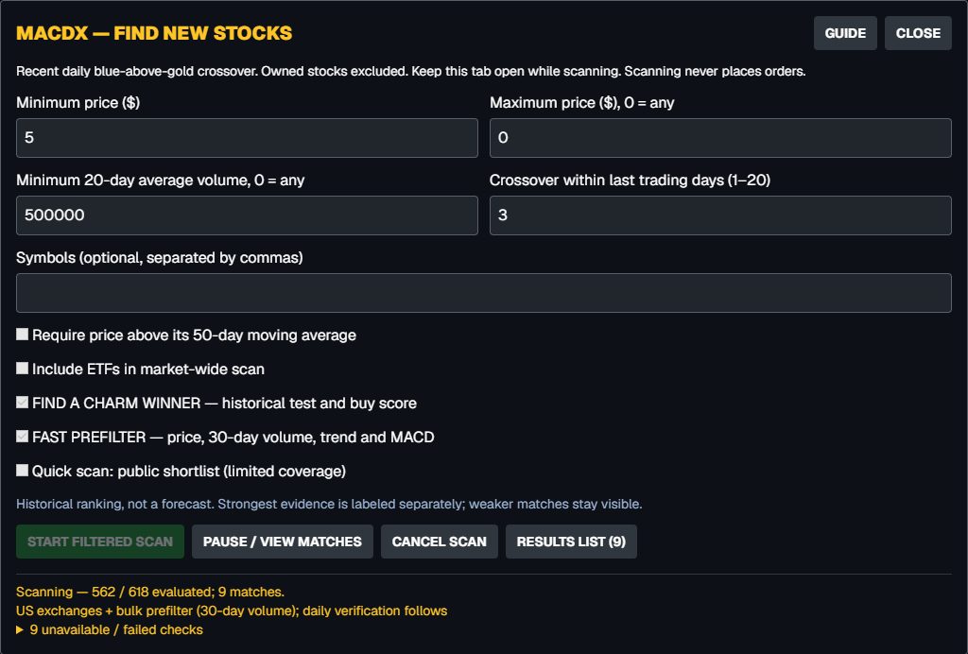
17
16
15
14
13
12
11
10
9
8
7
6
5
4
3
2
1
The chart stays behind the scanner. CLOSE hides the scanner; it does not cancel an active scan. GUIDE downloads the available guide.

What the progress means
562 / 618 evaluated means 562 candidates were checked from this search universe. 9 matches means nine stocks passed the current crossover filters. It does not mean nine proven winners. The unavailable / failed checks line expands to show errors.
Page 3 of 8

Remember
Pause to review and continue the same run. Cancel ends the run but keeps completed matches. A new START FILTERED SCAN replaces the previous result list. Results are kept in this browser session; reloading or changing account clears the scanner state.
Page 4 of 8

Set the search filters
1. Minimum price ($) Lowest share price to include. The shown preset is 5. Enter 0 for no lower price restriction.
2. Maximum price ($), 0 = any Highest share price to include. 0 means no upper limit.
3. Minimum 20-day average volume Minimum average shares traded per day over the latest 20 daily bars. The preset is 500000 shares. 0 removes the filter; this is share volume, not dollar volume.
4. Crossover within last trading days (1–20) The preset is 3. Blue must have crossed above gold within the last three completed daily bars and still be above it. Today’s unfinished daily bar is excluded.
5. Symbols Optional comma-separated symbols, such as MSFT, IESC, NET. Leave blank for the market-wide search. Other filters still apply, and owned stocks remain excluded.
6. Require price above its 50-day moving average Checked: require price above its 50-day simple average. Unchecked: remove this extra trend requirement.
7. Include ETFs in market-wide scan Checked: allow ETFs alongside eligible stocks. Unchecked: exclude ETFs from the market-wide universe.
8. FIND A CHARM WINNER Preset on. Run historical CHARM tests and calculate the buy score. Testing adds time. Weaker matches remain visible; STRONGEST EVIDENCE is a separate strict label.
9. FAST PREFILTER Preset on. Use a bulk market snapshot to check price, 30-day volume, MACD above signal and the optional 50-day rule. CHARM then verifies the recent crossover and 20-day volume using daily history. Uncheck for a broader, slower history scan.
10. Quick scan Use the public MACD shortlist for limited coverage. Leave unchecked for a wider search. An explicit Symbols list is not replaced by this
Page 5 of 8
11. START FILTERED SCAN Start with the selected filters. Fields and the start button are disabled while running. A fresh scan clears the previous candidates.
12. PAUSE / VIEW MATCHES Pause new history requests and open results so far. In-flight requests may finish. CONTINUE SCAN resumes the same queue without intentionally repeating completed checks.
13. CANCEL SCAN End the run and keep completed matches. Use Pause instead if you want to continue the same search later.
14. RESULTS LIST Open the retained candidates. The number in parentheses is the number of matches found so far.
15. Progress and failed checks Read the evaluated count, matches and source. Expand unavailable / failed checks to see individual errors. A broker authentication failure stops the scan; reconnect before retrying.
16. GUIDE Download the guide available from the Web2 screen.
17. CLOSE Hide the scanner. An active scan continues while the tab remains open. Use CANCEL SCAN to stop it.

Select charts from the results
1. Sort and select Click any column heading to sort; click again to reverse. Click a stock row to select it. Selecting a row alone does not load a chart.
2. Click LOAD CHART Open only the selected stock. The button is disabled until a row is selected.
3. Load another choice Click RESULTS LIST on the chart. Your list and sorting remain. Select another row and click LOAD CHART. The small arrow controls cycle through explicitly loaded MACDX charts only.
4. Return to the scanner RETURN TO SCAN, immediately after SELL on the chart, reopens the filters. Use CONTINUE SCAN if paused; use START FILTERED SCAN for a new search.

Page 6 of 8

Read the evidence and place a trade

Understand the results columns
STOCK identifies the candidate. CROSS DATE is the daily signal date. BUY SCORE / 100 compares conservative historical evidence, with higher scores first by default. It is not the percentage chance your next buy will profit.
CHARM WIN % is the share of resolved later-period test trades that made a net profit. TRADES is that sample size. MEDIAN NET % is the conservative middle trade return after assumed costs. A win-rate range means the two tested intraday paths differed. N/A means no usable estimate, not a zero chance of profit.
The buy score uses the 95% Wilson lower bound of conservative wins, counts unresolved outcomes as nonwins, and penalizes small samples. Nonpositive median return scores zero. Missing data or a large price-jump review flag gives N/A. For example, 100% from two trades means only that both past test trades won.

GET MORE EVIDENCE
For a chart loaded from MACDX, click GET MORE EVIDENCE. Review chart context, earlier and later test summaries, historical trade details, weaknesses and dated news. Recent highs and lows are reference levels, not price targets. News may be unavailable; earnings dates are not verified.
Tests use next-open entries, ATR-based CHARM rules fixed at entry, assumed 0.1% cost per side, two daily intraday paths, a 60-session limit and no overlapping entries. History is split 70% earlier and 30% later. Daily tests cannot reproduce every live price move.
Page 7 of 8
STRONGEST EVIDENCE requires the strict sample, sampling-bound, return, unresolved-trade and data-quality checks to pass. LIMITED / MIXED means some results exist but the standard is not met. NOT TESTED / INSUFFICIENT means usable test evidence is absent. Read the weakness text before comparing candidates.

BUY and SELL on the chart

1. Open the ticket BUY or SELL opens the existing order ticket with the displayed stock selected. This is the chart’s stock, not the MACDX command.
2. Review the trade Check the symbol, active broker, paper or live mode, quantity, order type and any price before submitting. SELL may prefill your owned quantity; verify it.
3. Submit deliberately Complete the ticket’s required confirmation. Scanning, selecting a result and loading a chart never submit orders. Check OPEN ORDERS or history for the brokers’s final status.
Page 8 of 8

